**Why Cloud computing ?**

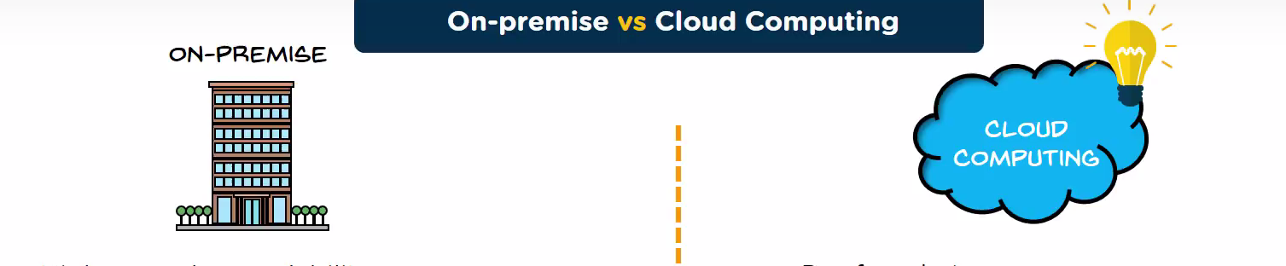

|  |  |
| --- | --- |
| Higher pay , less scalabality | Pay what you use  Scale up = pay more  Scale Down = pay less |
| Allot huge space for servers | No server space required |
| Appoint a team or hardware and software maintaince | No Experts requires for hardware and software maintenance |
| Poor data security | Better data security |
| Less chance of data recovery | Disaster recovery |
| Lack of security | High Flexibility |
| No Automatic updates | Automatic software updates |
| Less collaboration | Team can collaboration from widespread locations |
| Takes longer implementation time | Rapid implementation |
| Data cannot be accessed remotely | Data can be accessed and shared anywhere over the internet |

**What is Cloud Computing ?**

Rather than managing files on a local storage device , cloud computing makes it possible to save then over the internet

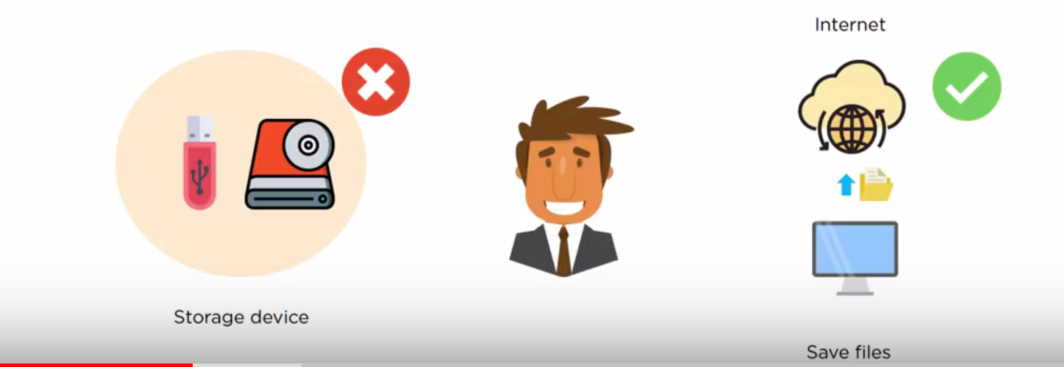

**Types of Cloud computing ?**

1. **Deployment Model**
2. **Service Model**

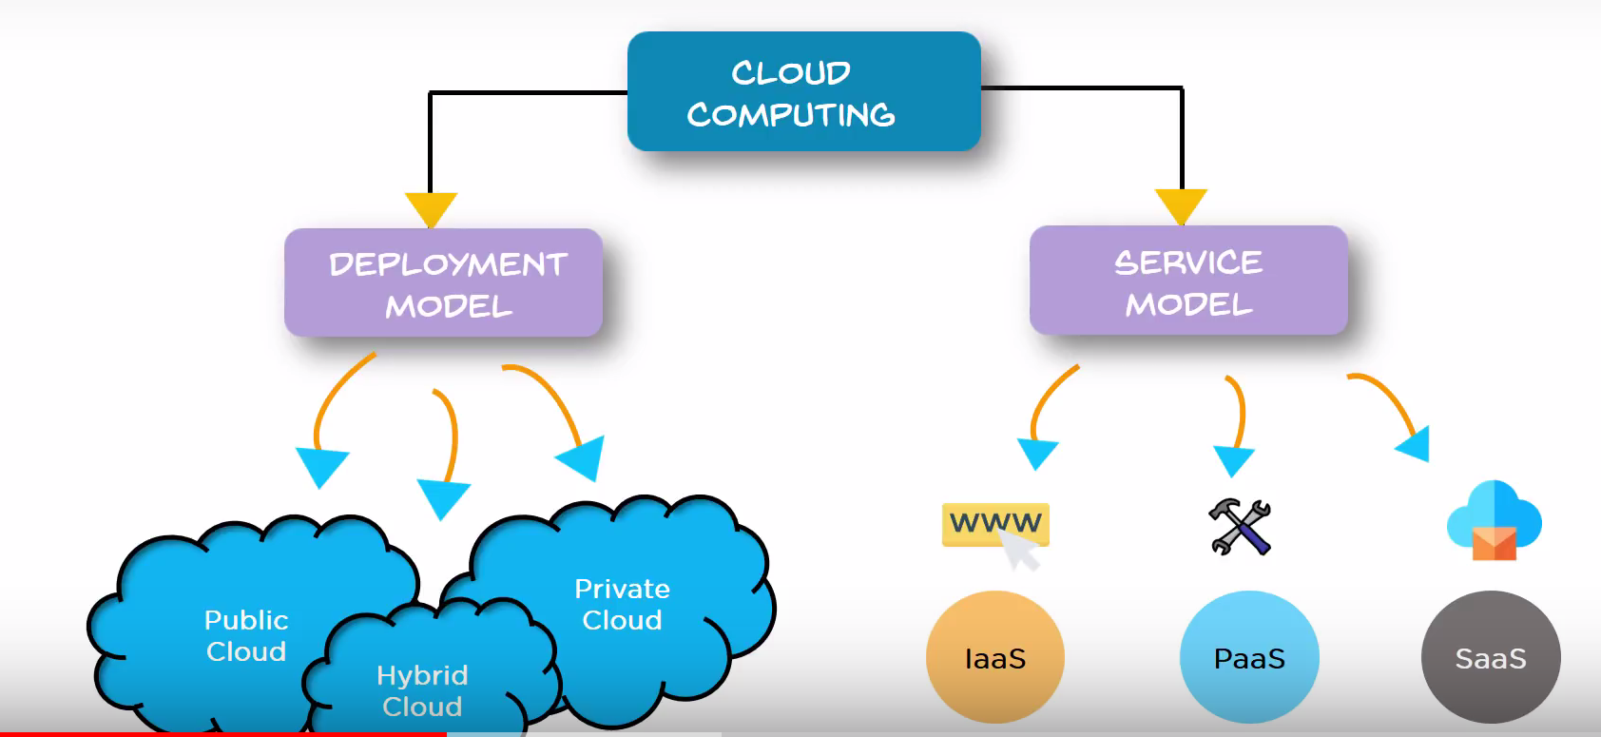

**Deployment Model**

1. **Public cloud**
2. **Hybrid cloud**
3. **Private cloud**

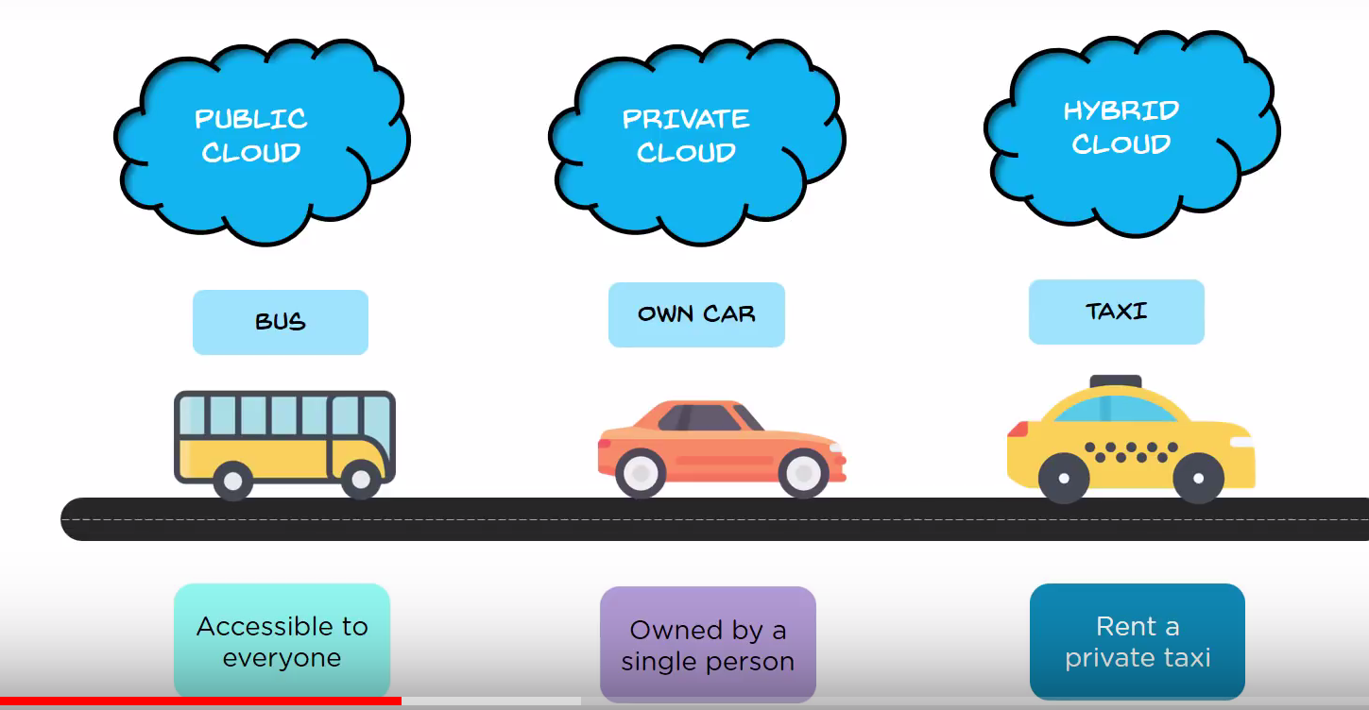

**Public Cloud**

**The Cloud infrastructure is made available to the general public over the internet and is owned by a cloud provider**

**Eg : AWS , Microsoft Azure, IBM Blue cloud and Sun cloud**

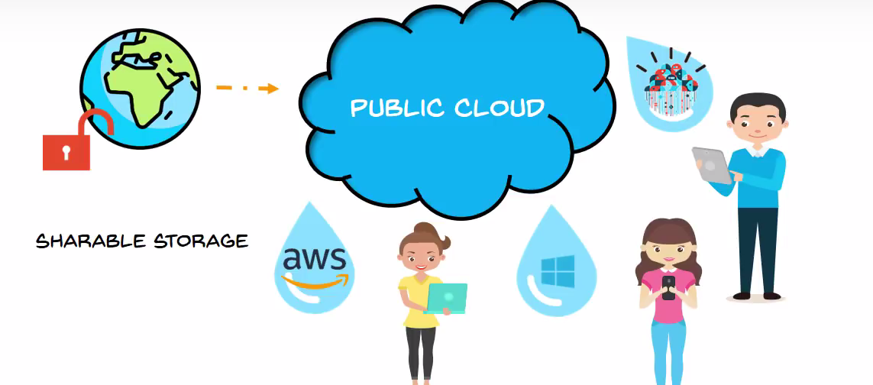

**Private Cloud**

The cloud infrastructure is exclusively operated by a single organization , it can be managed by the Organization or a third party and may exist on premise or off-premise

EG : AWS, VMware

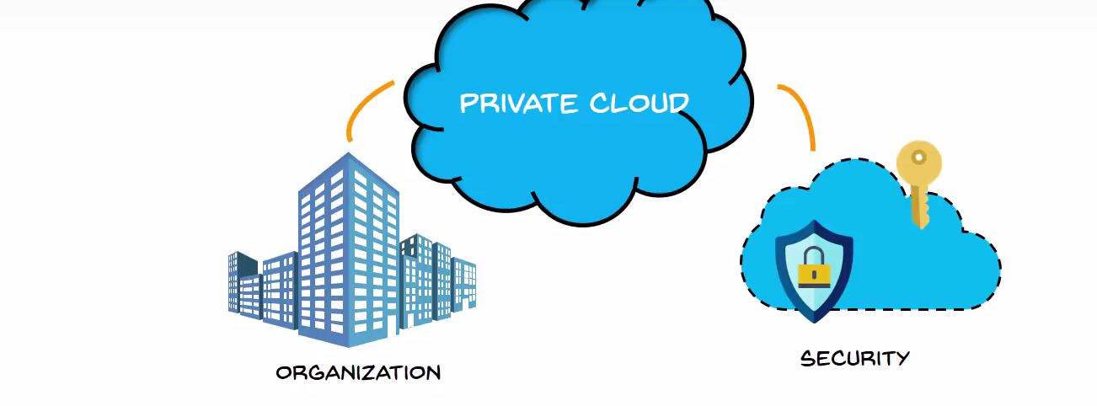

**Hybrid Cloud**

This consists the functionality of both private and public

EG: Federal agencies

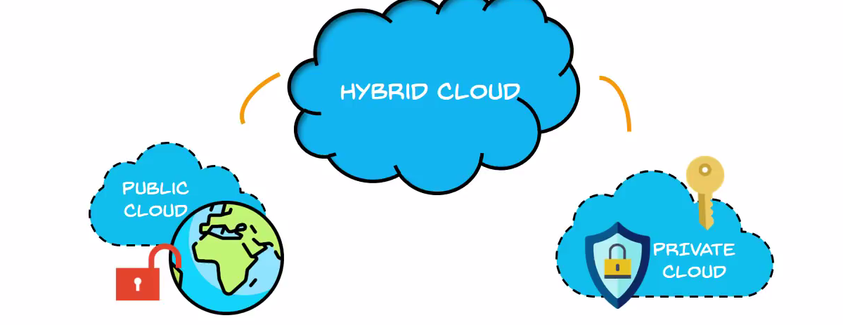

**Types of Service model**

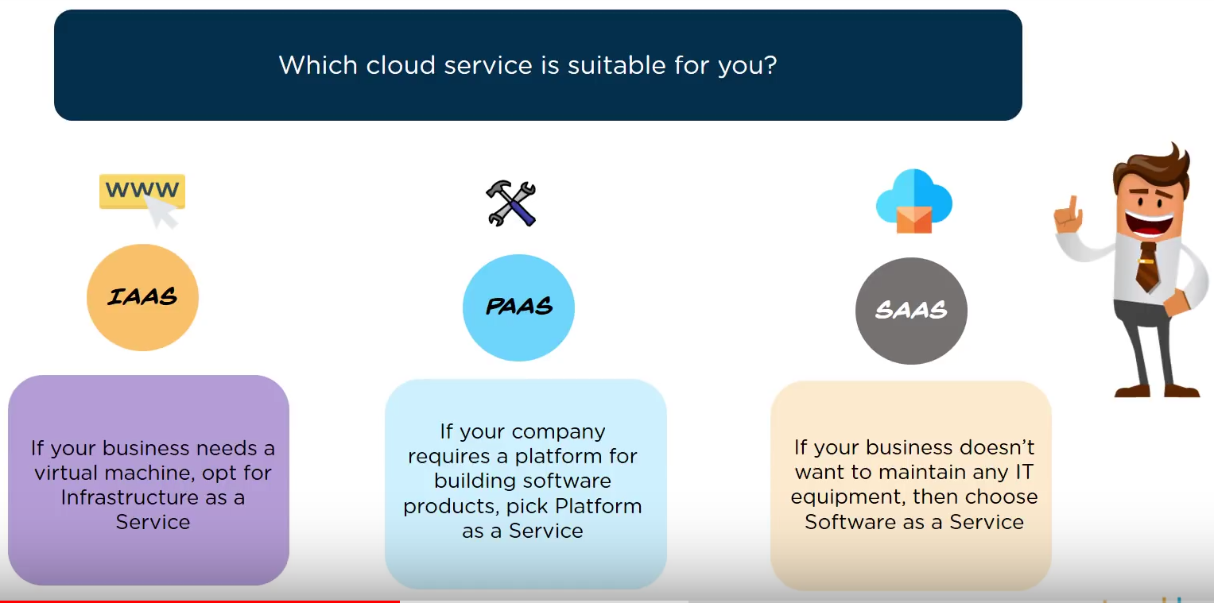

Difference between IASS , PASS , SASS

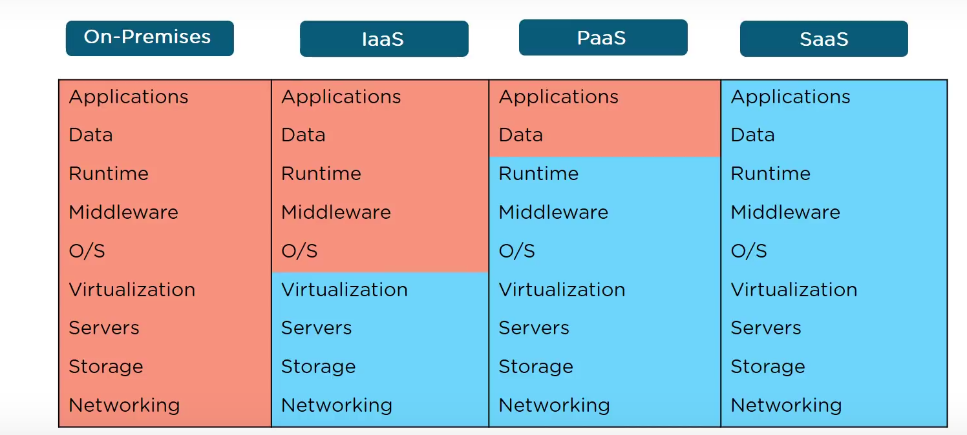 

**IASS**

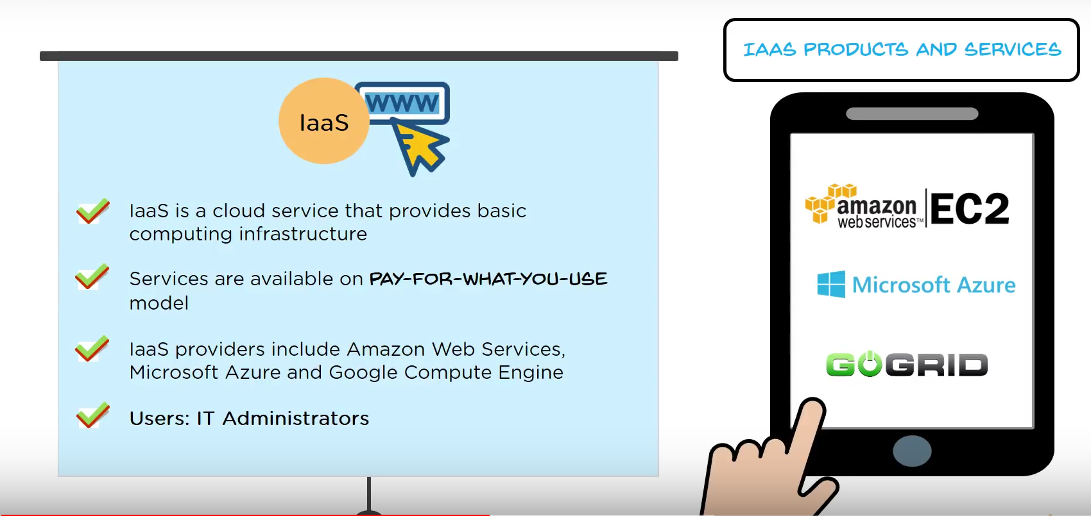

PASS

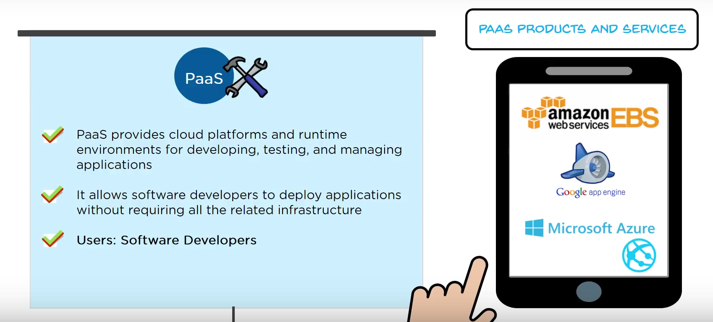

SASS

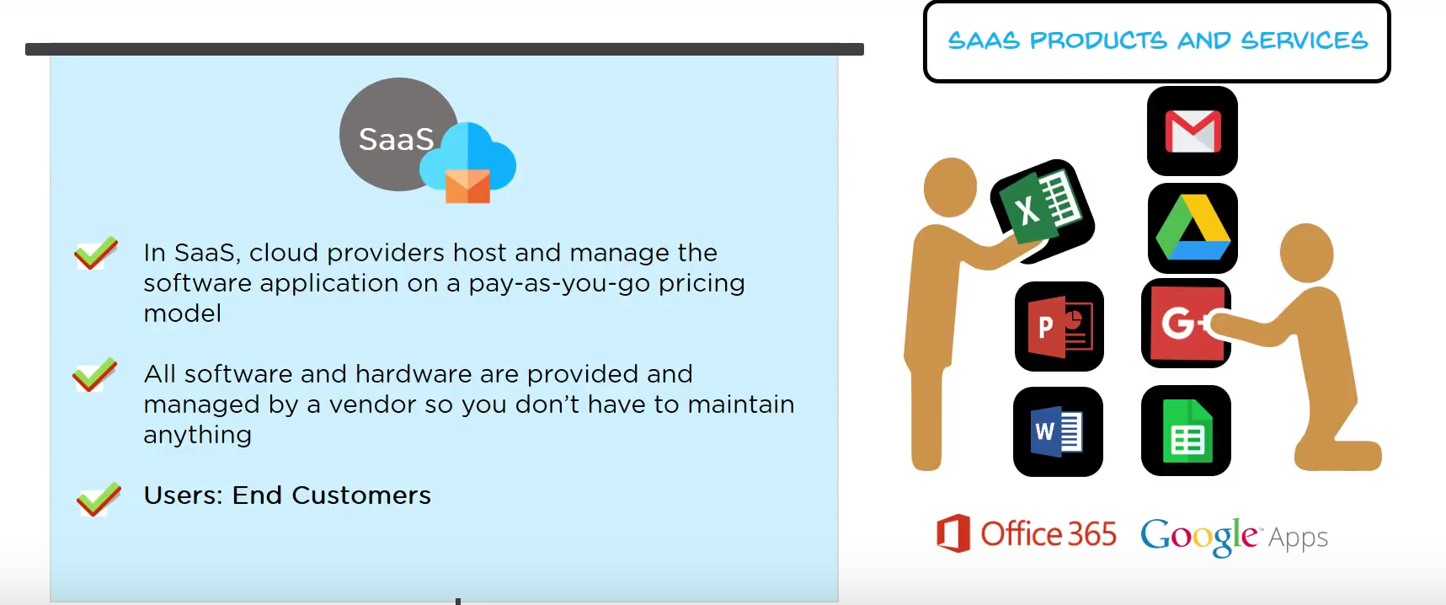

**Cloud Providers**

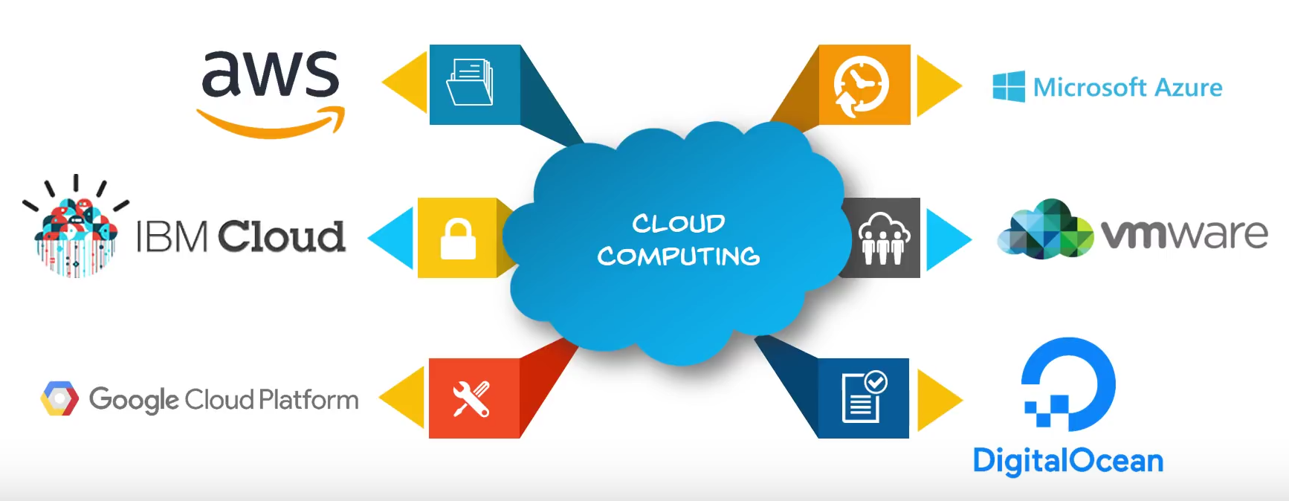

**Cloud Computing with AWS**

🡪Amazon Web Services (AWS) is a cloud service from amazon

🡪It Provides services over the network

🡪AWs services can be used to create and deploys and type of application in the Cloud

* AWS uses the subscription pricing model (pay for what you use)

**Life Cycle of Cloud computing**

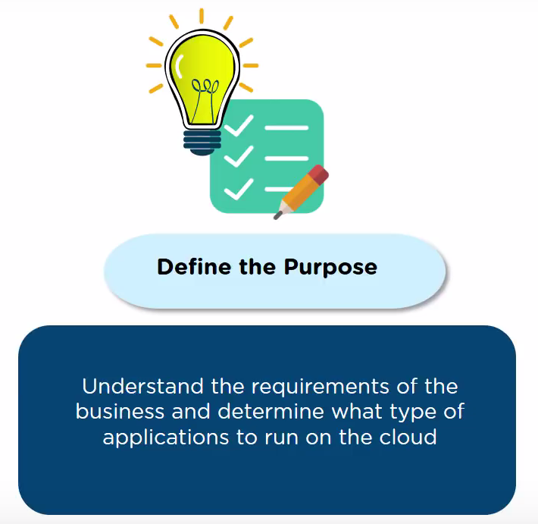

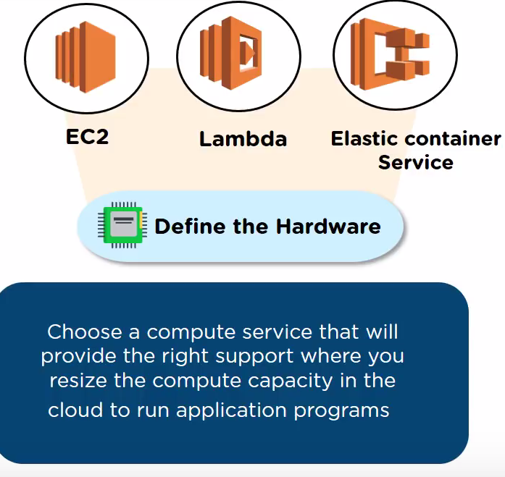

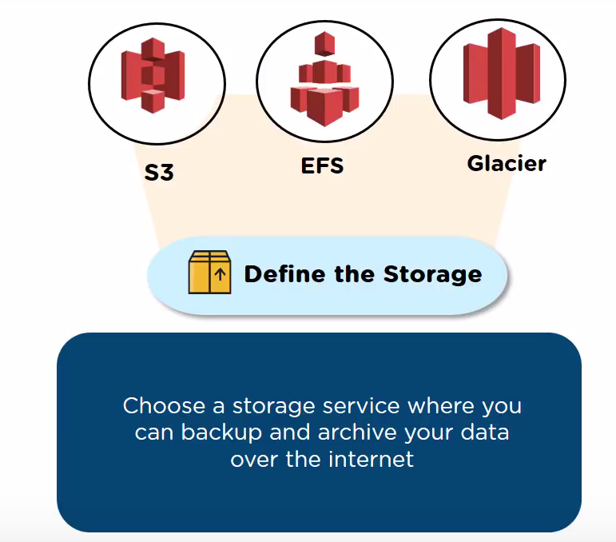

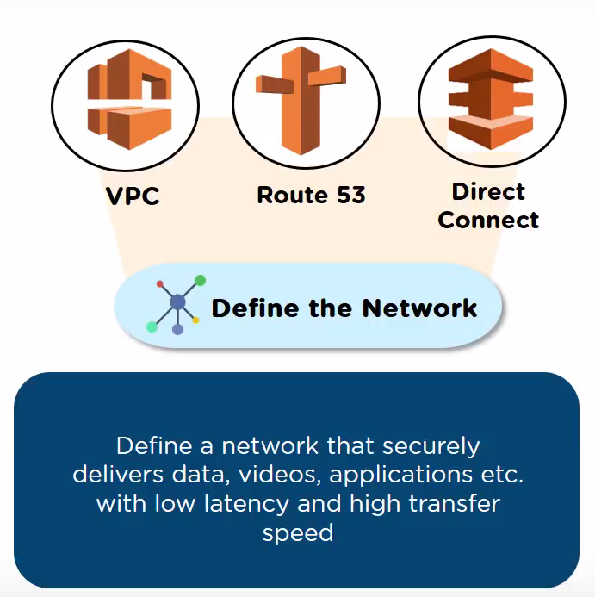

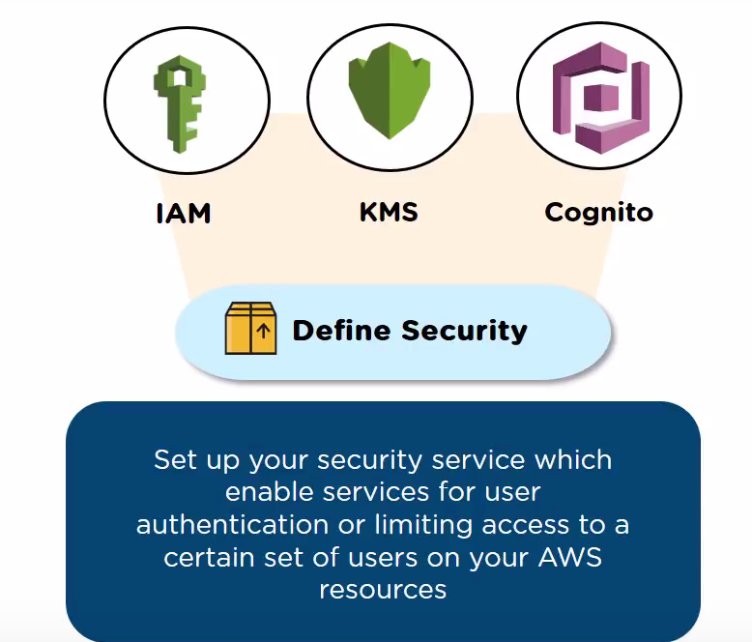

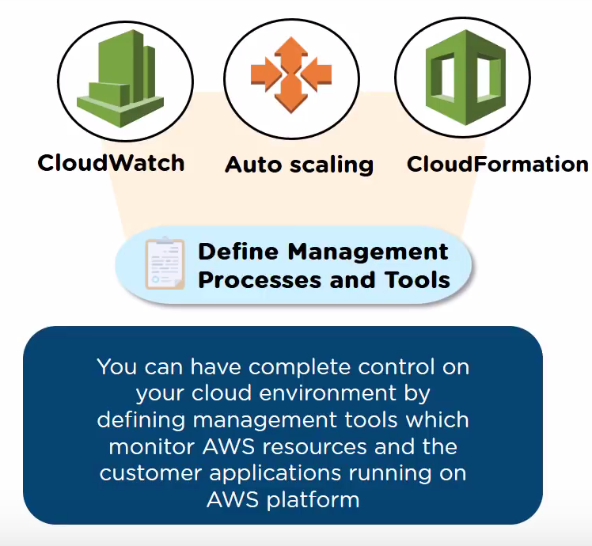

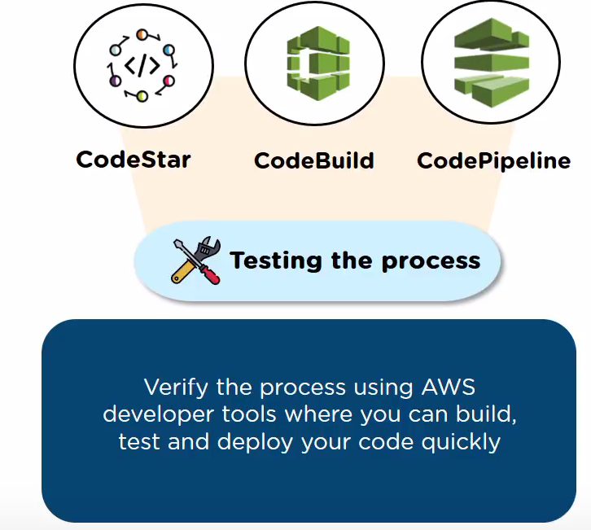

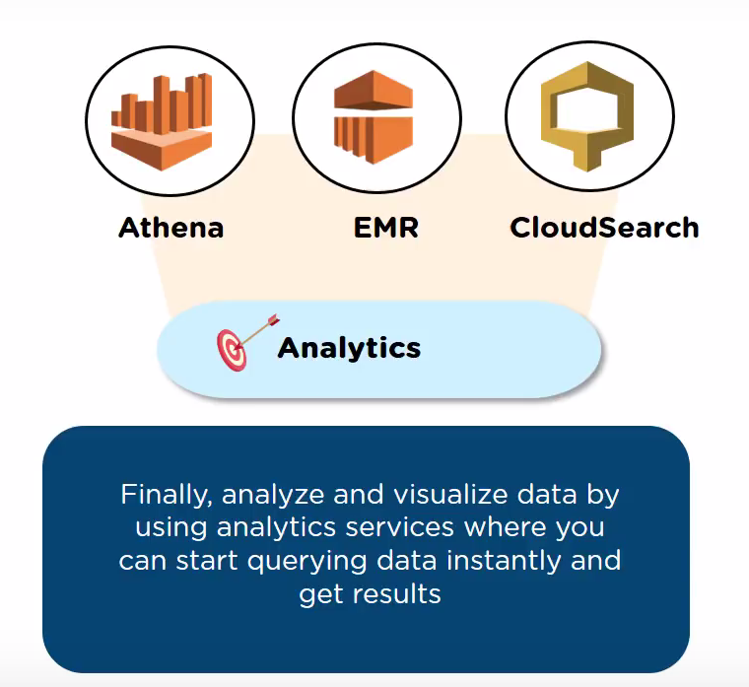

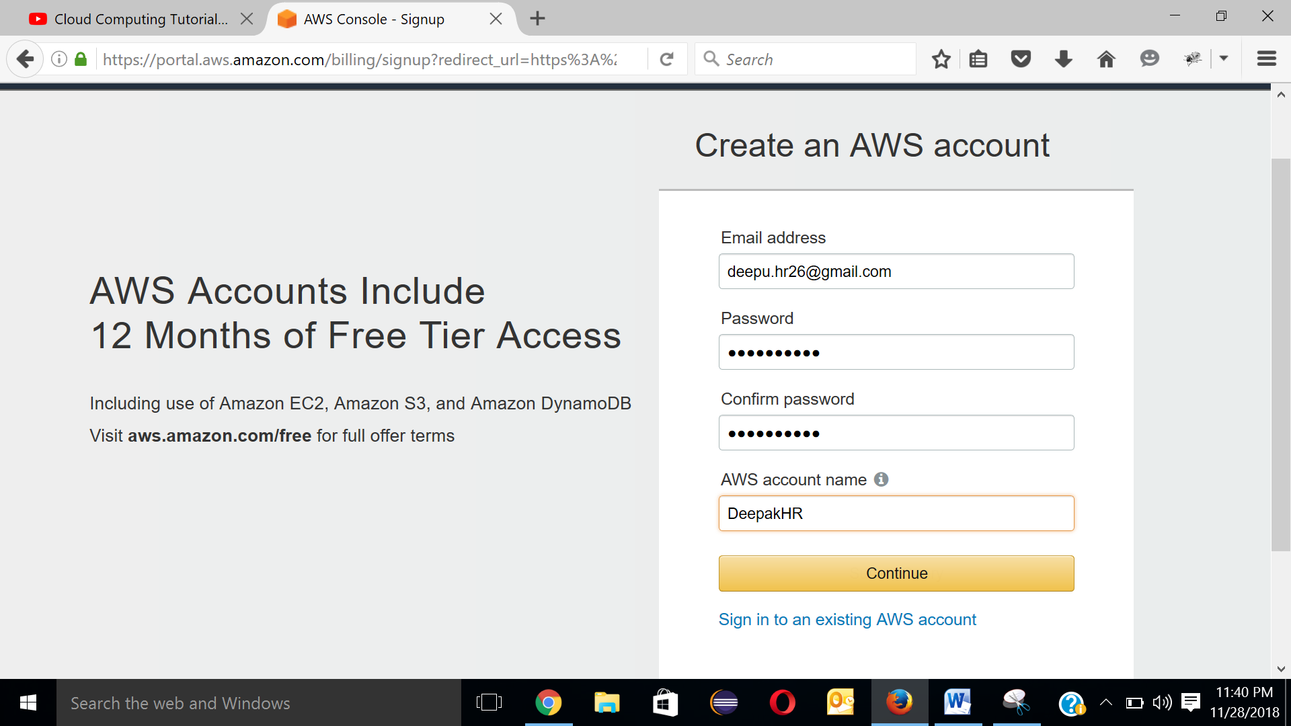

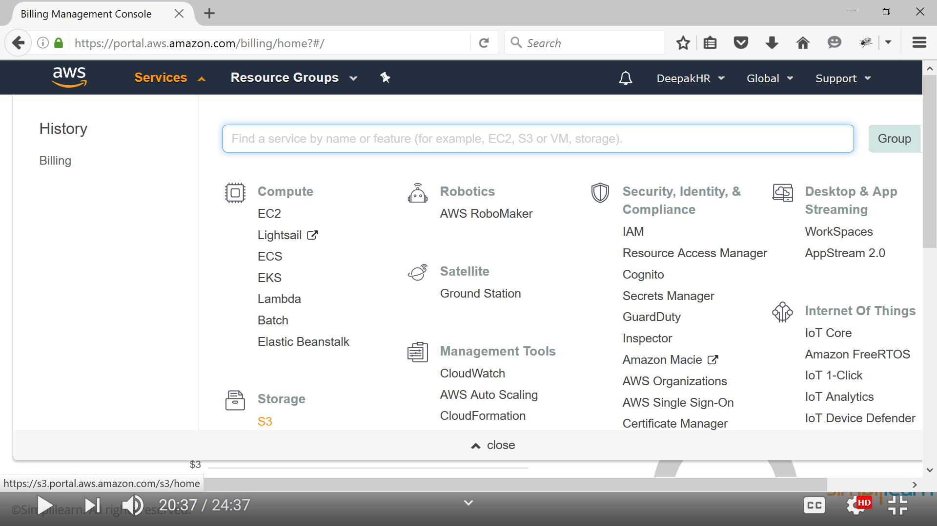

https://signin.aws.amazon.com/signin?redirect_uri=https%3A%2F%2Faws.amazon.com%2Fmarketplace%2Fmanagement%2Fsignin%3Fstate%3DhashArgs%2523%26isauthcode%3Dtrue&client_id=arn%3Aaws%3Aiam%3A%3A015428540659%3Auser%2Faws-mp-seller-management-portal&forceMobileApp=0

AccID : 411006404711

Deep@k123

<https://www.youtube.com/watch?v=IT1X42D1KeA>

Administrator/

JtikFJFvQGQR7&D34y!@jAHeUM7W5$BS